Website Photo Review
3 June 2019

Home Page x 7 pics

Toolmaking Wheelchair evac tool
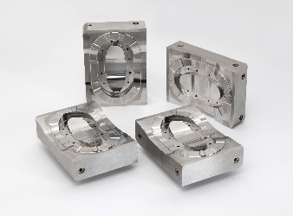
Product development Wheelchair evac moulding
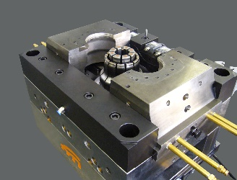 can get all pics tidied up as needed
Design technology Studbox design on screen
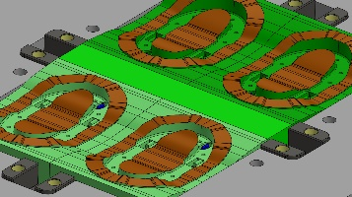
Inventor Partnership Beaker tool and moulds
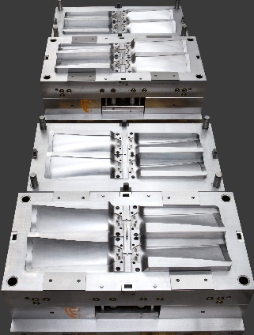
ISO9001 Kevin at CMM machine
Suggest we keep this one
Capacity & accuracy Kevin at spark eroder controls
Suggest we keep this one too

About Us
Big background pic Awning lens tool?
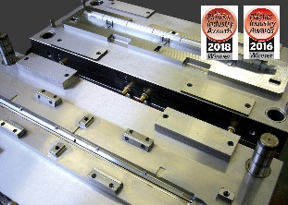
Inset 1 Award winning logos
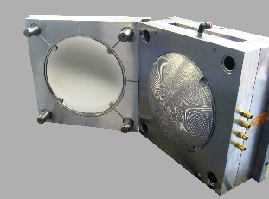
Inset 2 Blood buttons
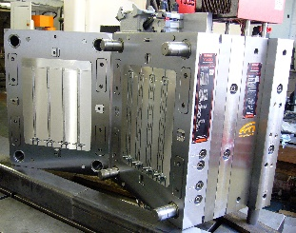 can get image tidied up

Toolmaking
Top half: Big background pic Beaker tool and mouldings

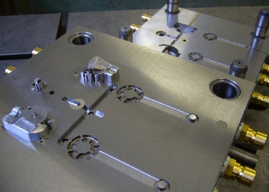
Bottom half: Scroll down background pic Employee at manual machine in black and white
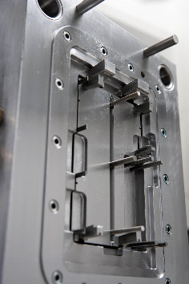

Design Technology
Big background pic NRV design with patent numbers etc
Suggest we keep this one

Inventor Partnerships
Big background pic Range of mouldings with Nookie Wedge prominen
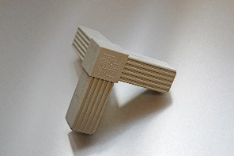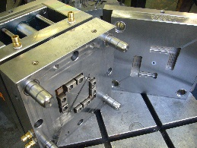

Product Development
Big background pic NRV tool
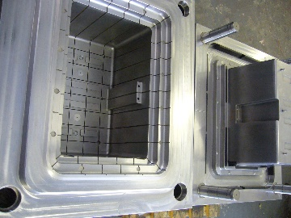

Experience
Top half: Blurred out background pic Machine trolley parts
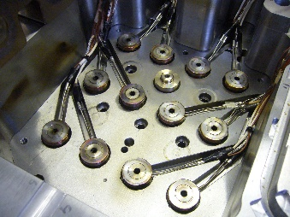
Various company logos

Bottom half scroll down:

[1] Photo gallery
43 different images

[2] Case Studies
WAR NRV 2 images – screen design, tool with moulding
Shocksafe shovel handle 1 image – cross section through handle
Snow shovel 3 images – design, tool and mould
Beaker 3 images – different views of beaker tool
Electrical wiring box 3 images – 2 of mould and one of tool
Nookie Wedge 3 images – 1 of product and 2 of tool
Wheelchair Evacuator 3 images – design, tool an mould

[3] Testimonials
WAR NRV 2 pics – same as above
Shocksafe shovel handle 1 pic – same as above
Nookie Wedge 3 pics – same as above
Electrical wiring box 3 pics – same as above
Wheelchair evac 3 pics – same as above
Tableware 4 pics – beakers, potato dish, pasta dish, plate

Contact Us / Recruitment
Background pic Plate on the sparker with blue fluid
Scroll down Careers Dan at Hurco
Apprenticeships Duncan teaching apprentice
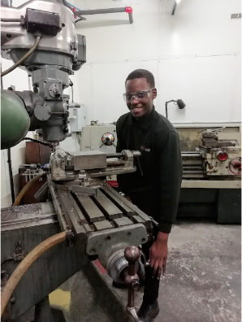
Job vacancies Kevin at sparker controls
